**Lotus Domino Connector Details & Port Used:**

The Lotus Domino connector uses the Lotus Notes client to communicate with Lotus Domino Server, for this Lotus Notes admin Client must be installed on the Falaina IAM server – requires customer to install this admin client on Falaina IAM server. The communication between the client and the server is implemented through the Lotus Notes .NET Interop (Interop.domino.dll) interface. This interface facilitates the communication between the Falaina and Lotus Notes client and supports access to Lotus Domino documents and views. The service account needs to have the following permission (Full Access administrators, Administrators, Database Administrators)

Domino - Notes client and Domino servers communicate using Notes Remote Procedure Call (NRPC), the default port number is **1352**.

**Environment Setup:**

* Notes Admin Client needs to install.
* NotesLib folder from Assembly folder in source needs to copy to deployment server.
* Environment Variable needs to set.
* Copy ProcessAdminP.dll & ResetPassword.dll to DomainService (InstallationFolder/DomainService)

|  |
| --- |
|  |

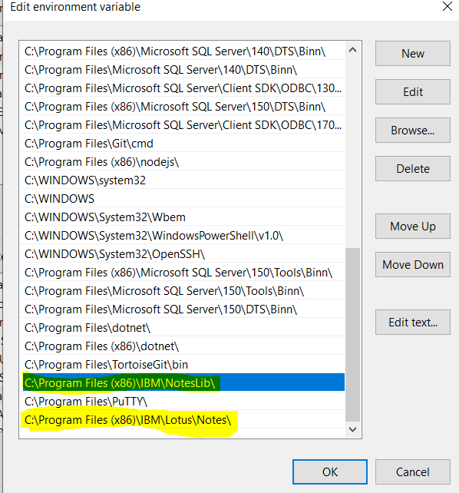

Both highlighted Notes admin client installation path and NotesLib folder needs to add in environment variables (for both System & User variables).

**Details Needed from customer side:**

* Need to know the Admin.Id file path and password.
* Need to know the OUCertifier Id file path and password.
* Need to know the location to create the User Id file, if it’s a shared drive we need the following
  + Drive Map path and Drive letter
  + Username
  + password
* Directory Server Name
* Replica Server Name
* Mail File Path format (mail\userid.nsf or mail\ou\userid.nsf)

**Configuration in Falaina:**

* Shared Drive related configurations in IM configuration Master
  + ISMappedDeriveForLNS
  + LNSMapDriveLetter
  + LNSConfiguredMapDrivePath
  + LNSMapDriveUsername
  + LNSMapDriveUserPwd
* Lotus noted email domina name in IACM configuration Master
  + DomainNameForLotusNotesAccount

**Lotus Notes Admin Client Screens:**

People & Groups is the default screen where we can register for new user and user life cycle activities can be performed.

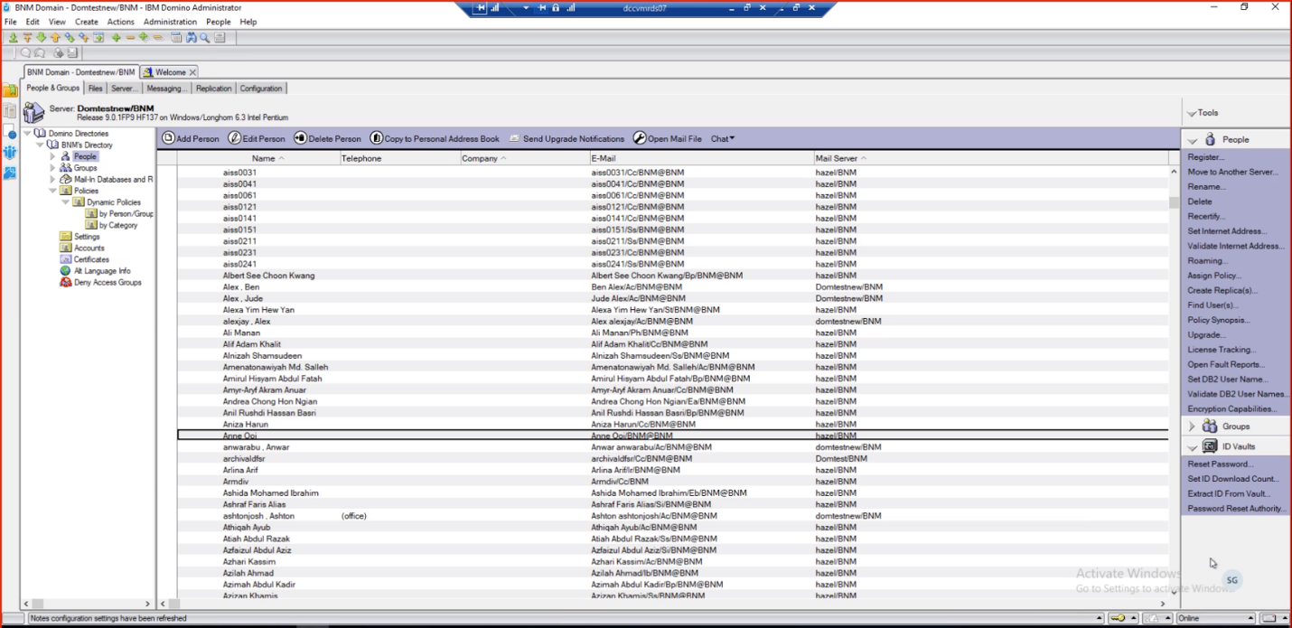

Under the People dropdown in the right-hand side, we can be able to perform User registration, recertify (Transfer), change domino server, basically all user related activities.

Under ID Vaults, we can be able to perform Password reset.

Document Properties is the place we can see all the properties set on the User Profile, the menu will be File -> Document Properties.

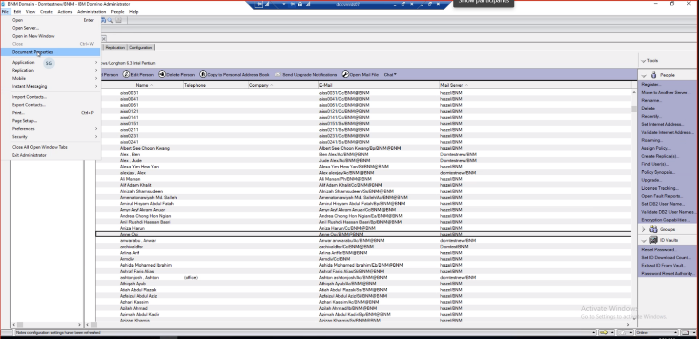

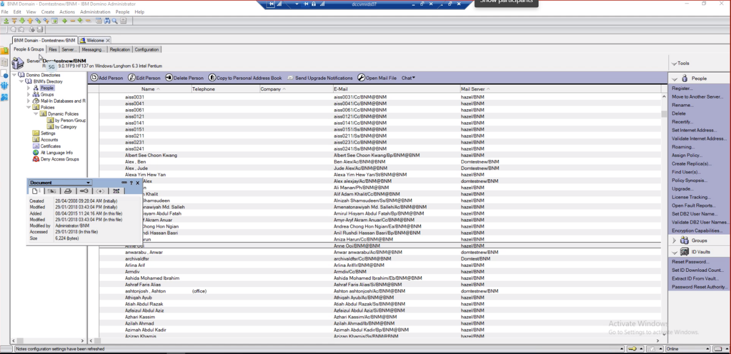

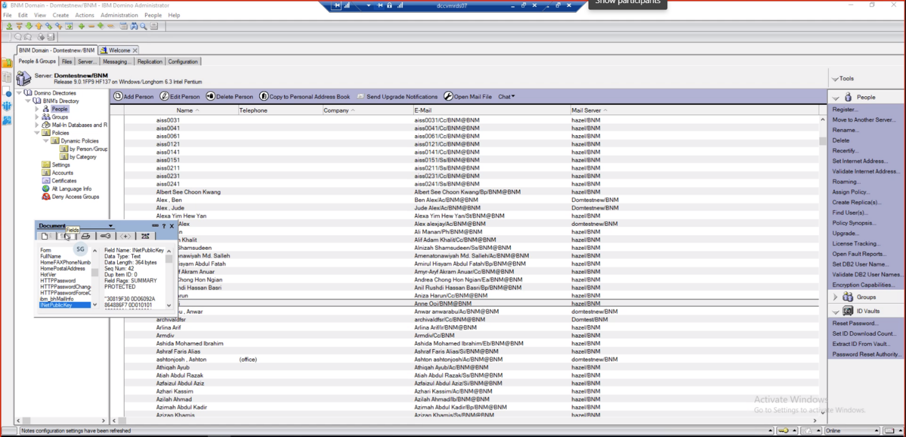

Administrator activities and log monitoring

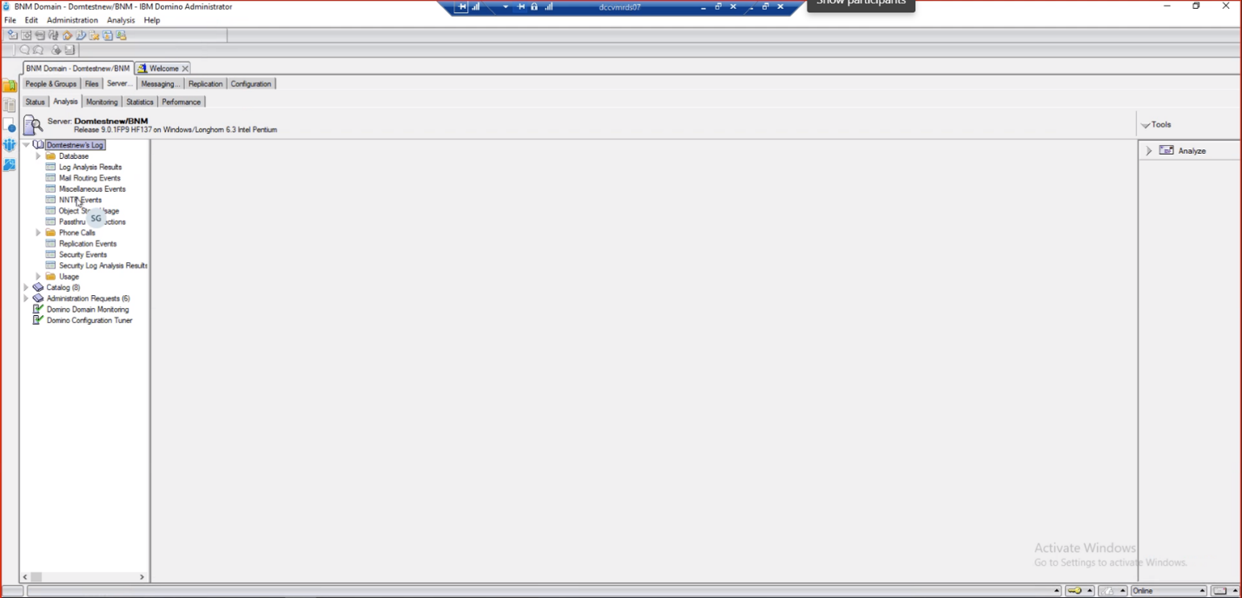

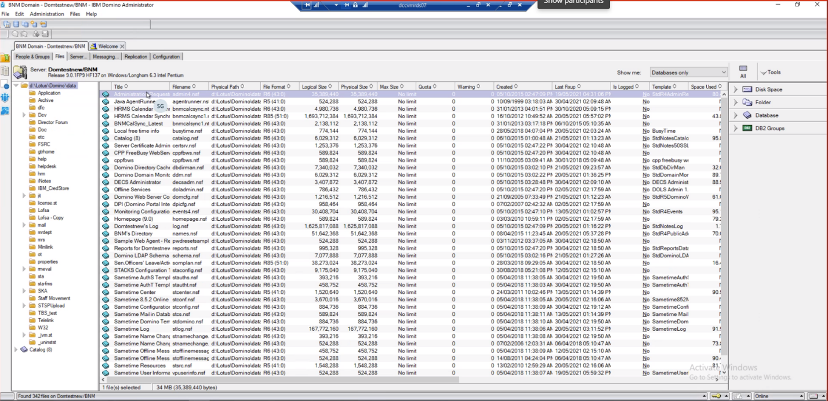

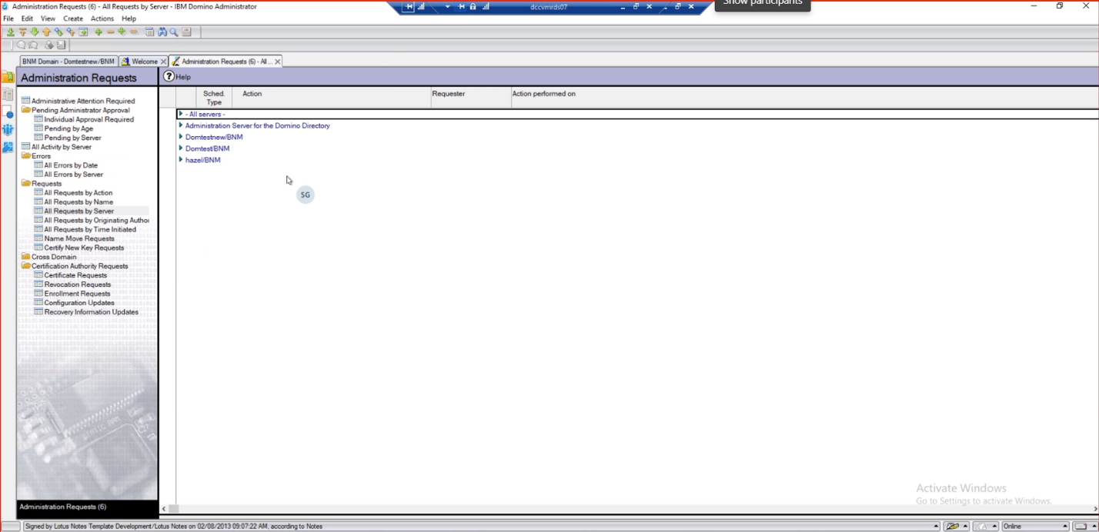

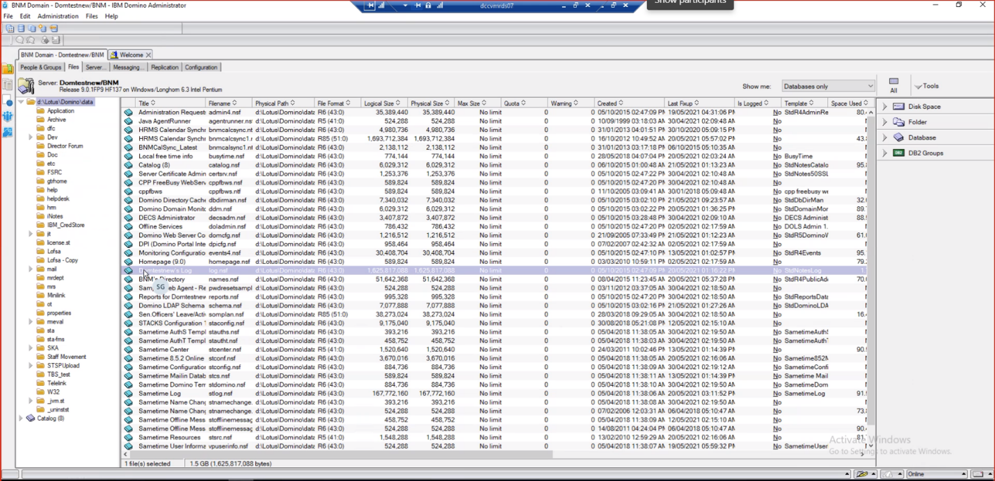

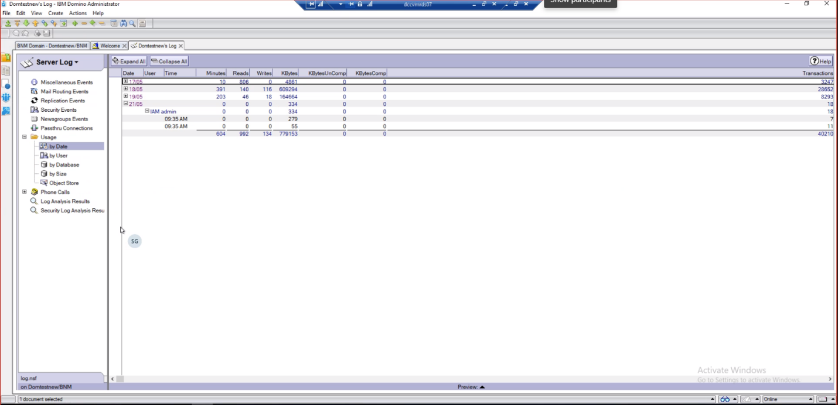

How to Register new user in lotus notes

After clicking Registration menu under the people tools, it will ask to select the OU Certifier and the password for that certificate.

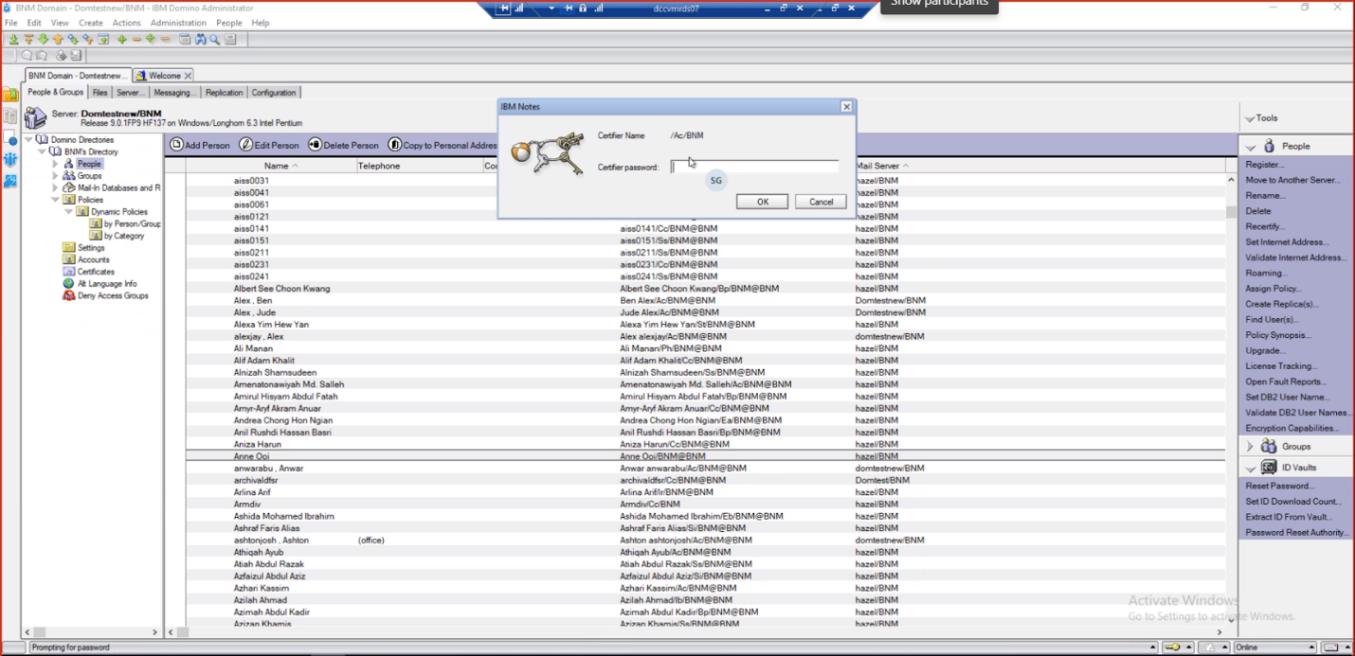

After that we can give the default basic properties of the user and select the domino registration server as well.

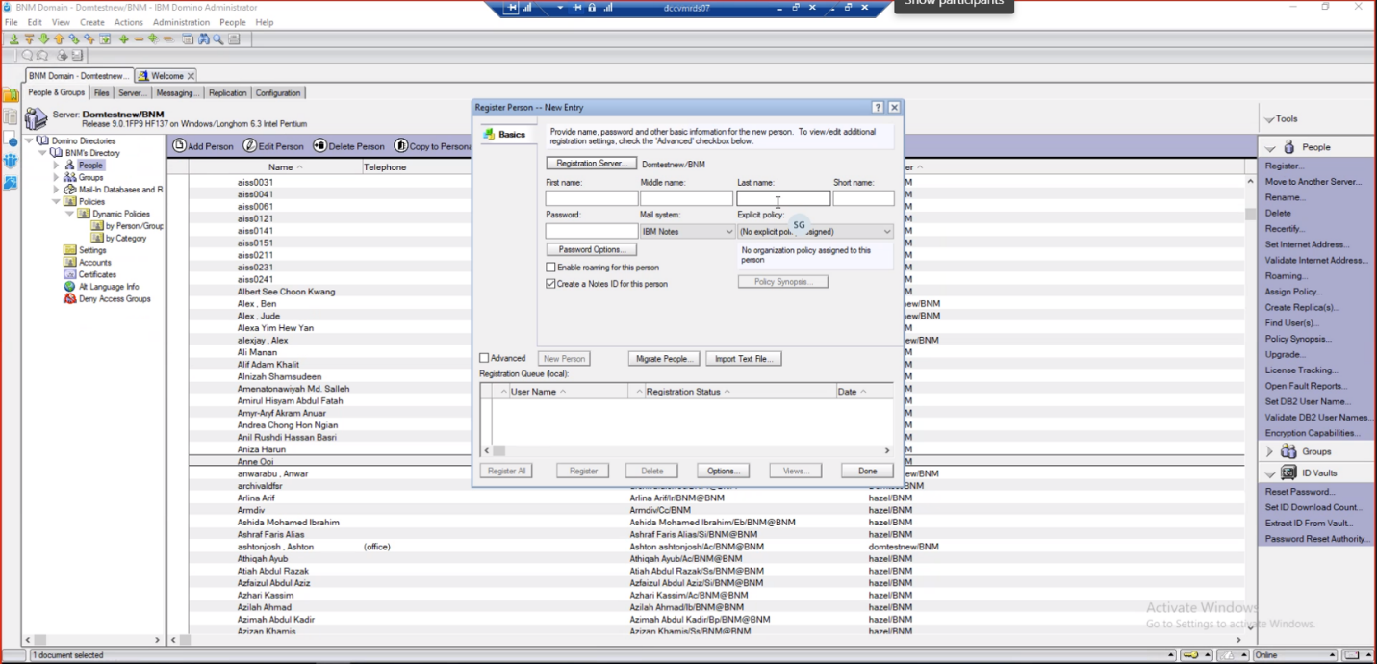

If you want to give additional attributes check the advanced option

